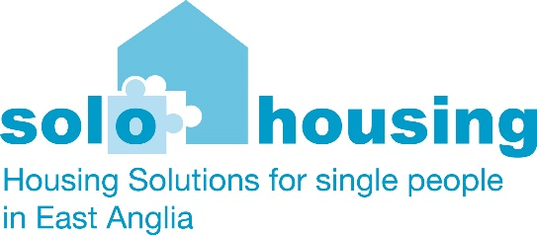

Administration and Office Manager
Solo Housing provides opportunities and solutions for single people experiencing homelessness and housing need across East Anglia. Based at our Head Office in Diss, the role of Administration and Office Manager has overall responsibility for creating a safe and welcoming reception to Solo Housing, managing the office administration and providing some administration support for staff working in other locations. The role encompasses the management and delivery of financial systems (Sage) and other systems which support our operational delivery. The role includes the line management of a small team to support with these services.
Main tasks:
- Manage financial and administration activities including financial information relating to properties.
- Monitor expenditure and income using Sage.
- Support the development of budget templates & cost codes to support the delivery of the business plan.
- Monitor individual project spend
- Develop, utilise and maintain standard financial and administrative procedures and use of appropriate software e.g. Sage, Rent Accounting systems.
- Complete relevant monthly journals, accruals, prepayments and project splits
- Manage the organisational delivery for customer contacts, reception and access for service users and stakeholders.
- Manage relevant systems and support contracts such as telephony and IT.
- Review all invoices and make the relevant payments in a timely manner using appropriate online banking systems.
- Review accounting discrepancies, undertake corrective actions and reconciliations
- Assist in implementing standard accounting policies.
- Ensure the preparation and maintenance of all financial records.
- Provide monthly and annual finance reports & undertake preparation for financial audit.
- Supervise and manage payroll processing, reconciliation, out of hours payments & expenses.
- Manage the Accounts Officer (Rents) in the provision of the rent accounting system and data processing
- Provide training and guidance to reception and admin staff and the Income Officer.
- Develop overall goals for the finance and administration departments.
- Identify and resolve financial and administrative issues.

Relevant experience and requirements:
- Proven office management, administrative or assistant experience
- Knowledge of office management responsibilities, systems and procedures
- Excellent time management skills and ability to multi-task and prioritise work.
- Attention to detail and problem-solving skills.
- Excellent written and verbal communication skills
- Strong organizational and planning skills.
- Proficient in MS Office packages, computer skills and knowledge of office software packages
- Proficient in use of accounting systems such as Sage , data and other administrative systems. Knowledge of rent accounting systems would also be advantageous
- Knowledge of clerical practices and procedures

Relevant skills:
- Demonstrable IT/ Microsoft application and use of systems skills
- Communication
- Analysis and Assessment
- Judgment
- Problem Solving
- Decision Making
- Planning and Organization – experience of working in a busy office environment
- Time Management and good organisational skills
- Accuracy and attention to detail
- Delegation
- Initiative
- Integrity
- Adaptability & knowledge of office systems
- Teamwork & a proffessional manner
- Budgeting
- Supervising
- Developing Standards
- Process Improvement
- Inventory Control
- Supply Management

Terms and conditions:
Hours 37.5 per week – Monday to Friday
Salary range - £26,339 to £30,054
Flexible working
8% employer pension contribution
28 days annual leave plus bank holidays

How to apply:
Please submit your CV and a personal statement to info@solohousing.org
Your personal statement should cover the following areas:
- Your interest in the role
- Examples of previous experience in covering the main duties of the role
- Evidence that you have the skills required
- Availability, notice period, reference details

