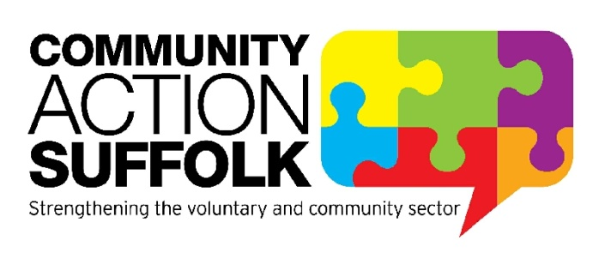
Covid-Support Buddies Specialist Officer

Hours: 37.5 hours per week per role
Term: 1 year fixed term contract
Location: Community Action Suffolk, Brightspace, Ipswich
Salary: £24,451 pro rata
Covid-Support Buddies is a new project funded by Suffolk County Council that will support and train volunteers from local groups and organisations to help reduce the spread of Covid-19 in communities. The Buddies will offer support to individuals who may be finding it hard to self-isolate, shield, quarantine or at risk of behaviours that may increase the spread of Covid-19. The Buddies will provide support and guidance to people to access food, medicine and supplies, as well as addressing feelings of loneliness and isolation. The volunteer Buddy will work with the individual to develop a plan to promote their independence and wellbeing.
Community Action Suffolk are recruiting for a Covid-19 Support Buddies Specialist Officer who has experience of designing and delivering projects and understands community development. They will ensure that the project reaches and understands the needs of Black Asian and Minority Ethnic (BAME) and disadvantaged communities in Suffolk. The role will be working directly with community groups and organisations and successful applicants will require good knowledge and experience of Volunteer Management.
We are happy to discuss any reasonable adjustments individuals may require in the recruitment process, or on commencement of post.
For more information please visit http://www.communityactionsuffolk.org.uk/vacancies/ for a copy of our application pack. Alternatively please contact Louise Bradshaw on louise.bradshaw@communityactionsuffolk.org.uk
Closing date: 9.00am Tuesday 16th February 2021.
Interviews will take place on Monday 22nd February 2021

