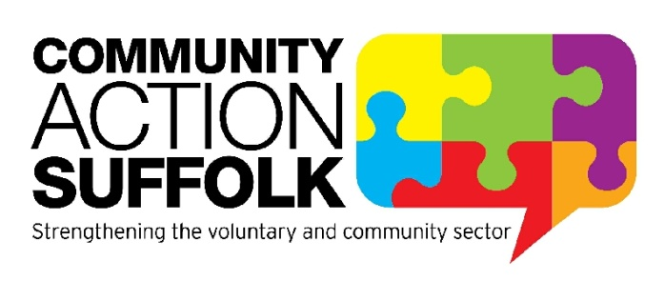
Diversity and Inclusion Worker Covid-Support Buddies

Hours: 22.5 - 37.5 hours per week – Job share and part time working requests will be considered
Term: 1 year fixed term Contract
Location: Community Action Suffolk, Brightspace, Ipswich with blended working
Salary: £24,451 pro rata
Start date: Immediate start
Covid Support Buddies is a new project funded by Suffolk County Council that will support and train volunteers from local groups and organisation to help people effected by the Covid-19 pandemic. The Buddies will offer support around shopping, medicine and supplies, as well as ongoing support to access community groups and activities for those at risk of loneliness. The volunteer Buddy will help the isolating individual to develop a plan and access support to promote their independence.
Community Action Suffolk are recruiting for a Diversity and Inclusion Worker to support the project reach and understands the needs of Black Asian and Minority Ethnic (BAME) communities in Suffolk. Excellent communication skills and a flexible approach to your work will be required as well as an understanding of voluntary and community groups in Suffolk.
We are happy to discuss any reasonable adjustments individuals may require in the recruitment process, or on commencement of post. We particularly welcome applications from people with lived experience. The hours for this post are negotiable, minimum of 22.5 hours and maximum 37.5 hours per week.
For more information please visit http://www.communityactionsuffolk.org.uk/vacancies/ for a copy of our application pack. Alternatively please contact Louise Bradshaw on louise.bradshaw@communityactionsuffolk.org.uk
Closing date: 9.00am Monday 3rd May 2021.
Interviews will take place on Monday 10th May 2021

