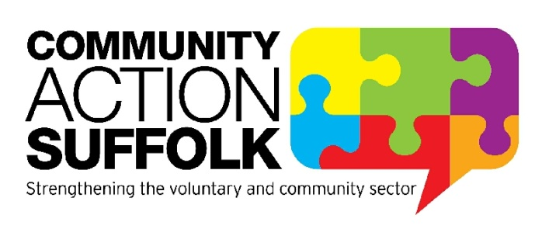
Support Services Assistant
Hours: 37.5 hours per week – part time and job share opportunities available
Term: 1 year fixed term contract
Location: Community Action Suffolk, Brightspace, Ipswich
Salary: £18,000 per annum

Community Action Suffolk is seeking an enthusiastic and resourceful Support Service Assistant with excellent customer and administration skills to support our diverse organisation.

Community Action Suffolk (CAS) is an infrastructure organisation for the Voluntary, Community and Social Enterprise (VCSE) sector. Our mission is to strengthen and champion community action in Suffolk by supporting the VCSE sector in its work.
As a Support Services Assistant you will provide essential support in the running of our Brightspace reception as well as administrative support to the HR function which requires attention to detail. You will be a self-starter with the ability to use your own initiative and meet agreed deadlines. Good customer service, interpersonal and team working skills are essential, as is the ability to communicate clearly both verbally and in writing. You’ll be a meticulously organised person who thrives in a busy and productive working environment.

We are happy to discuss any reasonable adjustments individuals may require in the recruitment process, or on commencement of post.

For more information please visit http://www.communityactionsuffolk.org.uk/vacancies/ for a copy of our application pack. Alternatively please contact Louise Bradshaw on louise.bradshaw@communityactionsuffolk.org.uk

Closing date: 9.00am Wednesday 30th June 2021.
Interviews will take place the week commencing 5th July 2021

