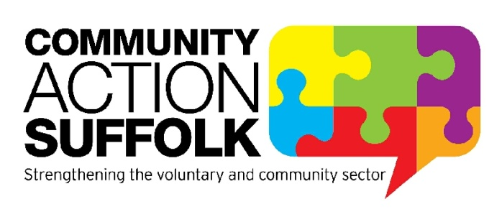
Kirkley Centre Supervisor

Hours: 25 hours per week
Term: Permanent
Salary: £19,500 pro rata
Location: Community Action Suffolk, Kirkley Centre, Lowestoft
Start Date: Immediate Start

Community Action Suffolk are recruiting for a Centre Supervisor for our Kirkley Centre premises. Working with Centre staff and volunteers this varied role involves supporting the public, community groups, room hirers and tenants, ensuring the smooth operation and maintenance of the Centre and its services.

The Kirkley Centre is unique community and business venue in Lowestoft. We serve the local community and voluntary sector along with the business community with offices that house local charities, businesses and a base for Community Action Suffolk. A variety of day hire rooms and services can be tailored to meet the client’s needs and budgets, from rooms for smaller meetings to spacious suites seating up to 80 delegates for conferences, presentations or AGM’s. The centre has close connections with the community and offers community and visitor information, events, signposting and advice on CAS services.

This role is a permanent post. We are happy to discuss any reasonable adjustments individuals may require in the recruitment process, or on commencement of post.

If you wish to understand more about the role please contact Kareena Chapman, Premises Manager on 01502 558353 or Kareena.chapman@communityactionsuffolk.org.uk

For more information please visit http://www.communityactionsuffolk.org.uk/vacancies/ for a copy of our application pack. Alternatively please contact Louise Bradshaw on louise.bradshaw@communityactionsuffolk.org.uk
Closing date: 9.00am Monday 12th July 2021.
Interviews will take place on: Thursday 15th July 2021.

