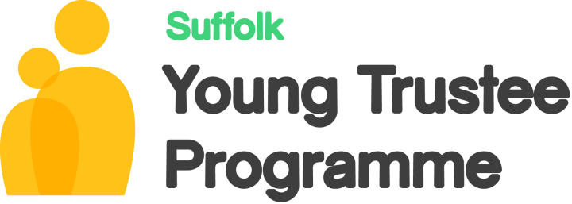Part of

Suffolk Young Trustee Application Form – For Young People

Name Date of Birth
Address
Email Telephone

Summary of education and qualifications

Summary of employment

Interests and volunteer experience

Why would you like to become a Young Trustee or Young Shadowing Trustee?

What interests, experience, skills and insights would you bring to a Trustee Board?

How did you hear about the programme?

Are you interested in a specific charity?

Do you have a disability or a health issue which you would like us to take into account?

References

Agreement – Community Action Suffolk

By ticking this box I am agreeing to this information being held on a database at Community Action Suffolk and Volunteer Suffolk website. I also agree to my personal details and this form being passed onto other charities, who are part of this programme. I am also agreeing to CAS/or hosting organisation contacting my references for further information.

By ticking this box I am agreeing to my information about this volunteer role being part of a media and marketing campaign to promote the importance of Young Trustees.
Please don’t hesitate to contact CAS on volunteering@communityactionsuffolk.org.uk if you have any questions about this agreement.

